

**Mess Management System (MMS)**





**Submitted To:**

**Sir. Khalid Hussain (Incharge Database Lab)**

**Prepared By:**

**Muhammad Yamin 021-19-0029**

**Muhammad Fahad Shahzad 051-19-0003**

**BSCS-IV Section B**

**Sukkur IBA University**

Contents

Abstract: 1

Introduction and background: 2

Problem statement: 2

Literature Review: 2

Project Technical Approach & Methodology: 3

Front-end: 3

Backend Technologies: 3

Tools: 3

Project Timeline 3

Work Division 3

Group Members 3

ER Diagram 4

Expected output of Project (Final Product) 6

Abstract:

Sukkur IBA University is now recognized as one of the top universities in Pakistan. Students from all over the Pakistan are rushing forward to get admission in this university. The university itself is also providing admission to many students in different programs including NTHP, STHP and Direct Admission etc. Therefore, all hostels are full of students. The mess managers of those hostels are also students in this university. So, they have to devote their personal time for the meal of their fellow students. Because management of a mess is not a child’s play, it takes a long time and, in this way, they remain weak in study.

This Mess Management System Project is a web-based application. The purpose of this project is to provide easiness to mess managers and students. They just need to login and update the units and accounting just by clicking buttons. They don’t need to work on paper and bother themselves any more. Students (other than mess managers) can login, view the menu, check their daily units, view the remaining and paid amount and can daily view the updated unit price. This system is also going to help them to keep check and balance in a proper and acceptable way.

Introduction and background:

The use of technology has increased dramatically in the last couple of decades. Machines (Robotics) are being used in every field of life. Business and accounting are also performed through computers. FBR is monitoring Taxation system, Transaction management and marketing by online means. Therefore, by seeing all the above examples, we have decided to make a computerized mess management system.

This project is going to have a very user-friendly interface. It contains multiple pages, on which users can go and select their relevant details.

Problem statement:

Mess managers were previously working on paper sheets to keep record. Now it is an uphill task to follow that conventional method. Therefore, this mess management is being made for the ease of those mess manager.

Literature Review:

The Mess Management System (MMS) is being made to provide quality food to students, easiness to users and to maintain proper check and balance system. This system is disturbed (web-application) system. It is an adaptive and responsive site so user can access it on either their desktop, personal computer or mobile devices. It will provide a number of facilities such as daily unit checking, price checking, daily expenditure and unit price checking. It is completely understandable and contains a lot of convenience for users. This system will store all the records in MySQL database. Therefore, data will be saved efficiently, permanently and can be retrieved as per need.

# Project Technical Approach & Methodology:

## Front-end:

* Thymeleaf Template Engine
* HTML
* CSS
* Bootstrap
* JavaScript

## Backend Technologies:

* Spring Framework(Java)
* Spring Boot
* Spring data JPA with Hibernate
* Lombok
* Spring Web
* Maven
* Spring boot DevTools
* MySQL JDBC Driver
* Spring Security

## Tools:

* Java Development Kit 1.8
* MySQL Community Server and Tools (Workbench)
* Jet-brains IntelliJ (Ultimate Edition)

# Project Timeline

Maximum 15 days are required to complete the whole project

# Work Division

Front end + Backend = Fahad Shahzad+Yamin Collaborations on GitHub is shown

# Group Members

* Muhammad Fahad Shahzad
* Muhammad Yamin

# ER Diagram

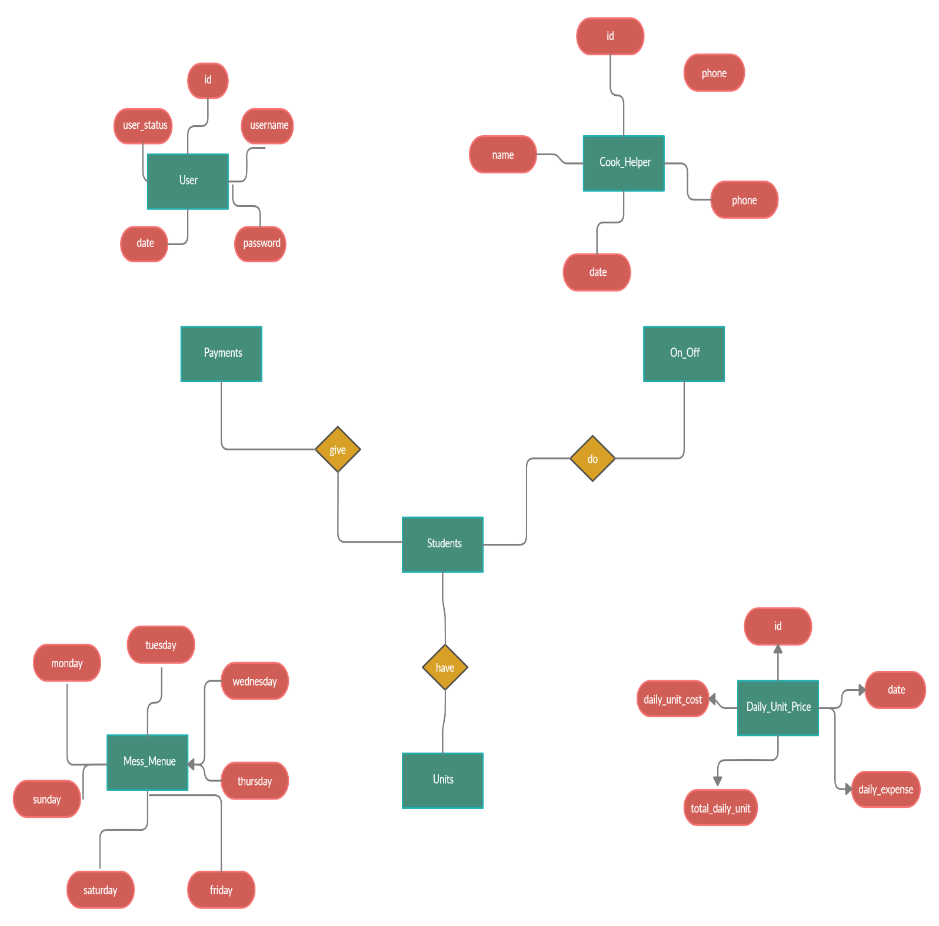

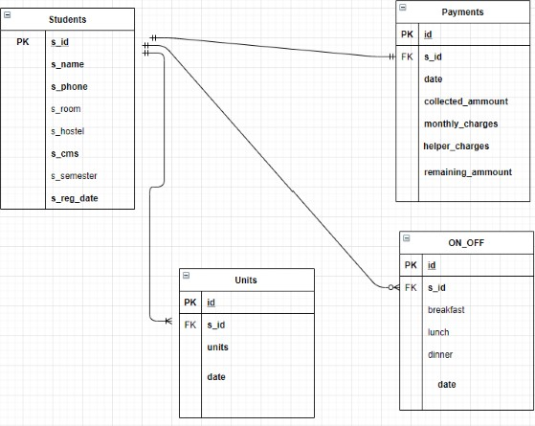

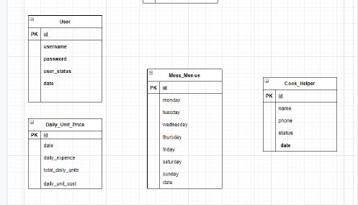

# Expected output of Project (Final Product)

Our project will be able to perform multiple operations and transactions in an easiest manner for mess managers and students, and also will provide some out of box features for reusability of the database and the code. It will be secure for admin panel authorizations.